Joseph & Potiphar’s Wife “I Will Be With You Wherever You Go” Magnet Craft
The Lord was with Joseph in prison.
Psalm 139:7-12 tells us the He will be with us wherever we go.
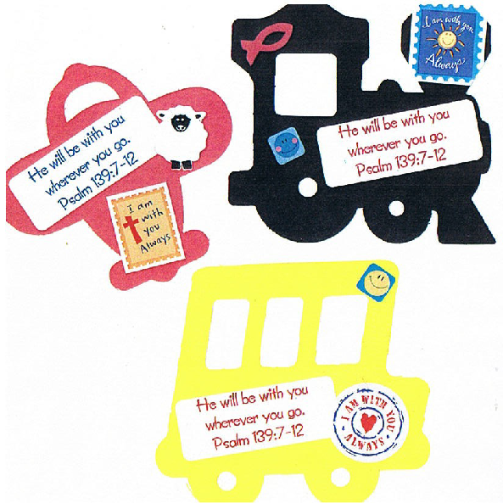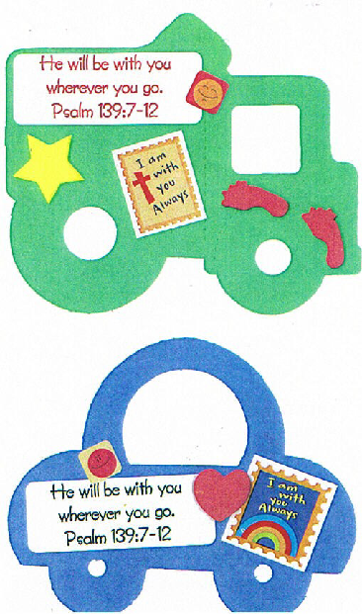

Directions:
- Choose a transportation shape
(www.punkydoodles.com)
- Place Genesis 39:21a verse sticker on back of shape
- Place Psalm 139:7-12 sticker on front of shape.
- Add “I am with you” sticker to front of shape
- Decorate open space of front of craft with 1 or 2 additional stickers
- Decorate with markers or glitter pens as you would like!
- Add a magnet to finished craft!
Joseph & Potiphar’s Wife “I Will Be With You Wherever You Go” Compass Craft

The Lord was with Joseph in prison.
Psalm 139:7-12 tells us the He will be with us wherever we go.

Directions:
- Choose a compass (www.orientaltrading.com 56/9087)
- Decorate with markers, paint and stickers

